Payload Electronics — Component Research
Sensor picks, system diagram, MCU choice, storage plan, risks, and fall next steps

Sensors

Pressure & temperature
Same chip measures both.
Spec | BMP390
Accuracy | ±3 Pa (≈ 0.25 m altitude)
Speed | up to ≈200 Hz
Interface & power | I2C/SPI, <650 µA
Cost | ≈ $10

Vibration
Measures shock and vibration through flight, including ignition and parachute deployment.
Spec | ADXL375
Range | ±200 g
Bandwidth | ≈ 1 kHz
Interface & power | I2C/SPI, ≈145 µA
Cost | ≈ $15
Pick: ADXL375 — ±200 g range, won't clip on shock.

Humidity
Adds relative humidity to the pressure/temperature reading.
Spec | SHT40
Accuracy | ±1.8% RH, ±0.2 °C
Also measures | Humidity & temperature only
Interface & power | I2C, low power
Cost | ≈ $6–$8

System Diagram
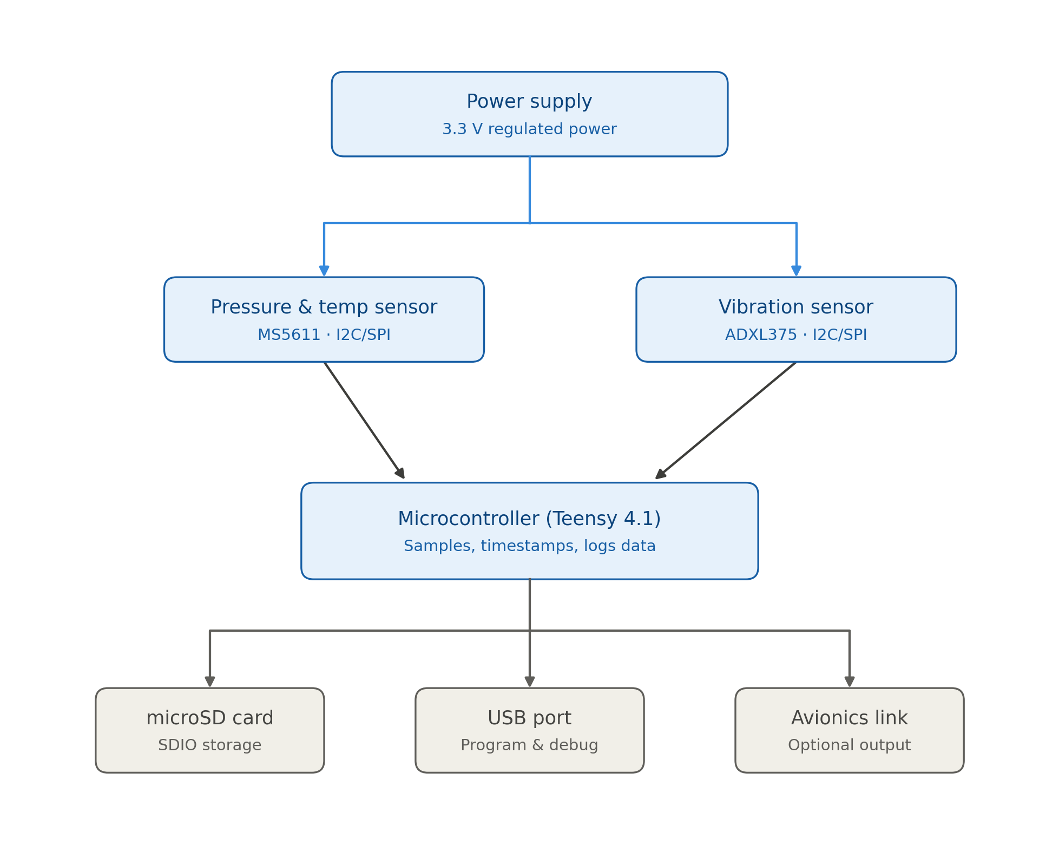
Power flows from the regulator to both sensors and the microcontroller. Sensors report over I2C/SPI to the Teensy, which timestamps and logs each sample to the microSD card. USB handles programming; the avionics link is optional.

Microcontroller: Teensy 4.1
Spec | Teensy 4.1
Speed | 600 MHz, single core
Memory | 1 MB RAM / 8 MB flash
SD card | Built-in, fast slot
Radio | None — quieter near GPS/altimeter
Timing | Nothing competes for CPU time
Price | ≈ $31.50
Pick: Teensy 4.1 — cleaner sampling loop, built-in SD slot, no radio nearby. ESP32 is the pick for wireless telemetry or a tight budget.

Storage Plan
Channel | Rate | Data per flight
Pressure & temp | 100 Hz | ≈ 0.6 MB
Vibration | 800 Hz | ≈ 4.8 MB
Total (packed binary) | — | ≈ 5.4 MB
As plain-text CSV instead of packed binary: ≈ 30–45 MB per flight. An 8–32 GB microSD card covers a full season many times over. The Teensy timestamps every sample from one shared clock, so pressure and vibration data stay aligned.

Major Risks
- Sensor clipping — not enough range cuts off shock data.
- Power sag at ignition — give the regulator margin to avoid a reset.
- Slow SD writes — buffer in RAM so a slow write doesn't drop a sample.
- Loose wiring — use locking connectors and strain relief.
- Shared-bus lockup — split sensors across separate I2C/SPI buses.
- Corrupted log file — flush/close the file periodically.
- Radio noise — keep sensor wiring short and away from trackers or altimeters.

Fall Next Steps
- Breadboard the MS5611 + ADXL375 on the Teensy 4.1 and confirm logging works at full speed.
- Measure real power draw, size the battery and regulator, and test recovery from a brief power dip.
- Shake-test the prototype (or fly it non-critically) to confirm mounting and sample rates actually capture what we need.

Sources
Datasheets and vendor pages: TE Connectivity/Amsys MS5611-01BA03; Bosch Sensortec BMP390 and BME280; Analog Devices ADXL375 and ADXL377; TDK InvenSense ICM-42688-P; Sensirion SHT4x; u-blox NEO-M9N and NEO-M8N; PJRC/SparkFun Teensy 4.1; Espressif ESP32-DevKitC-32E.

